- Description of equipment, including operating parameters (energy, amperage, etc.)

Accelerator Description
Description  Linear Electrostatic Ion Accelerator  (Modified Crockoff-Walton deuteron accelerator) | Manufacturer  In-house
Equipment Name  MIT Linear Electrostatic Ion Accelerator (LEIA) | Date of Manufacture  Initially ~1990s, with continuous upgrades
Model Number  N/A | Date of Installation  ~1990
Serial Number  N/A | MIT Property Tag Number  N/A

Accelerator Properties
Accelerator Type and mode of acceleration | Linear electrostatic potential drop
Particle accelerated | Deuterium, rarely He-3
Particle (Beam) Energy (MeV) | Maximum: 150 kV  Nominal: 135 kV
Continuous or Pulsed | Continuous
Beam Current/pulse (mA) | Maximum: N/A  Nominal: 10 uA
Pulse Rate (Hz) | N/A
Beam Pulse width (usec) | N/A
Target Material | ErD₂ and ErT₂ (Est. Feb/2016). He-3 is implanted into ErD₂  biannually.
Radiations produced  (Type and Energies) | Neutrons (several MeV), photons (several MeV)
Target Yield | 10⁷-s⁻¹ (max) and 10⁶ s⁻¹ (nom)
Duty Cycle (maximum) | N/A
Use Factor | 1 hr / week (annual average), 40 hr/week (maximum)
Dose Rate | Unshielded:  Shielded: background outside of vault
Other

- Description of intended use of equipment:
Describe in sufficient detail how the instrument will be utilized. Indicate power output for common experiments and how safety features apply to usage (Attach protocol sheet if needed).

The MIT Linear Electrostatic Ion Accelerator (LEIA) is an accelerator-based fusion products generator. It is used primarily for development of nuclear diagnostics for Omega, Z, and the NIF. It is capable of producing D-D and D-3He fusion products at rates of 10⁷-s⁻¹ and 10⁶ s⁻¹. It consists of an ion source, a beamline with in-situ diagnostics, and a cylindrical chamber with an ErD2 target. A charged-particle diagnostics suite, consisting of Surface Barrier Detectors (SBDs), a pre-amplifier and a Multi-Channel Analyzer (MCA) are used as the primary diagnostic for charged fusion products. Nuclear diagnostics, including charged-particle spectrometers and neutron yield detectors, are developed and cross-calibrated against this suite.

- Description of Engineering Controls:
Describe shielding, accelerator controls, interlocks, warning devices, High Radiation Area Controls, and beam containment systems. (Attach documentation or SAD as appropriate)

An interlock system is used for securing the vault during operation. Warning red lights are also flashing when the interlock system is being readied. In addition, a remote camera system allows operators to view the inside of the vault in real-time.

- Description of administrative controls
Describe operating procedures, posting and labeling, operator training, configuration changes, radiation monitoring, and access control. (Attach documentation or SAD as appropriate)

A physical sweep of the vault is performed during the interlock readiness procedure. A radiation area sign is placed on the entrance to the vault and is the only accessible entrance to the vault. Maria Gatu-Johnson is the facility operator and supervisor.

Radiation area monitoring badges are placed both inside and outside of the vault and the results are reported quarterly.

Interlock and Startup Procedure:

- Once preliminary equipment checks have been successfully performed, one should enter the vault and ensure any workers present vacate the vault.
- The last person exits the vault with the accelerator grounding rod in hand and places this rod at the bottom of the stairs, approximately 1.5 meters high, which acts as a visual blockade.
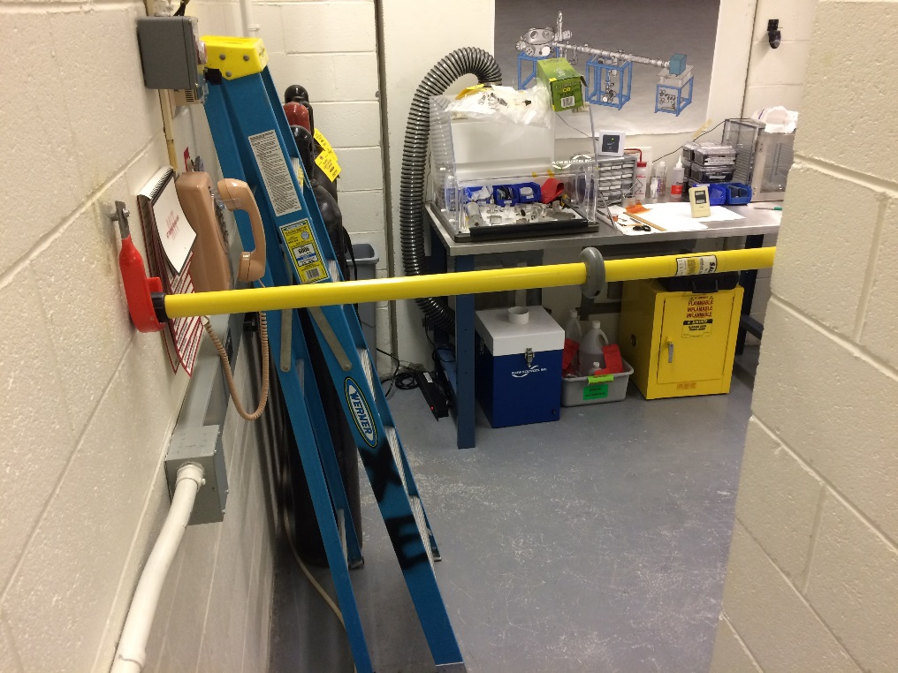

- The vault door is shut, which closes the door interlock switches.
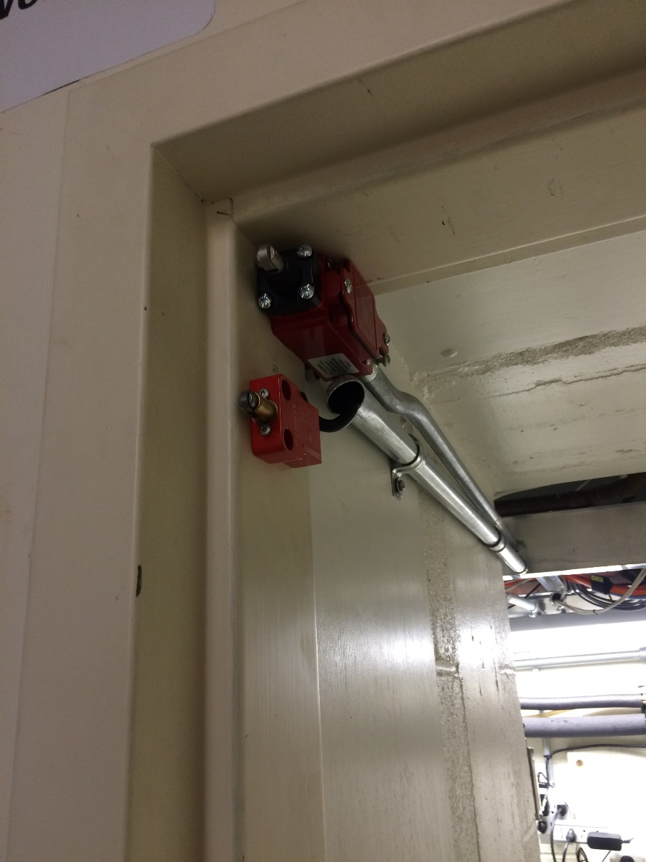

- The HV ready switch on the computer is toggled from OFF to ON, allowing the system to turn on the high voltage.
- The position of the plasma power key is verified that it is in the ON position.
- The red warning lights should be blinking.
- The accelerator is ready to be operated.

- Ancillary Hazards
If applicable, provide information related to Airborne Hazards and controls, briefly other hazards such as RF, and Lasers that may be present. (Attach documentation or SAD as appropriate)

Confined RF hazards exist, however, high voltage is the primary ancillary hazard. In addition, rupture of the vacuum view port glass could lead to damage to a person close by, however, this occurrence is highly unlikely.

- List radiological monitoring equipment and survey meter(s) available; include quantity, model, type and serial number

1 GM meter, serial number: 92729.
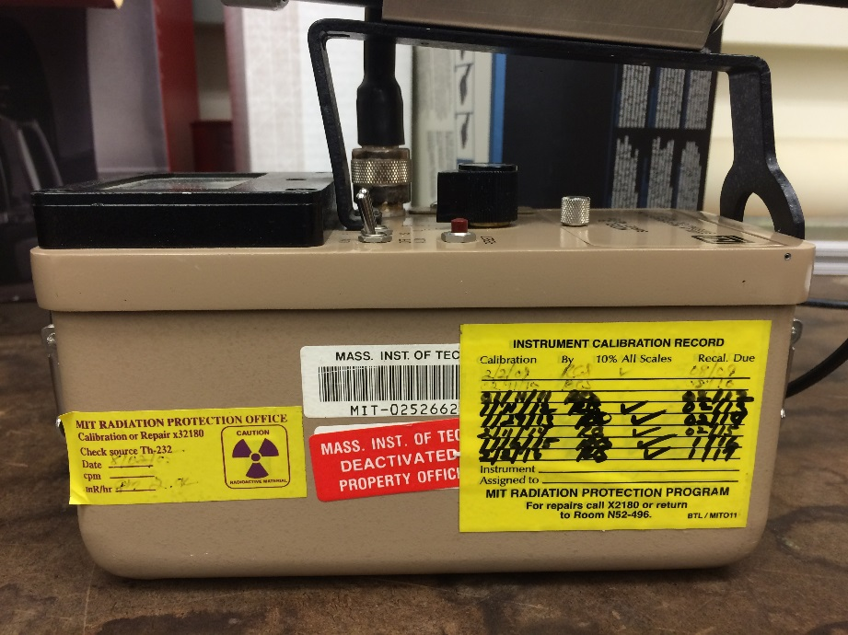

- Location of Use
Please include a figure showing location of intended use. Will this be restricted access? Show room safety features (use below or attach as appropriate and indicate)

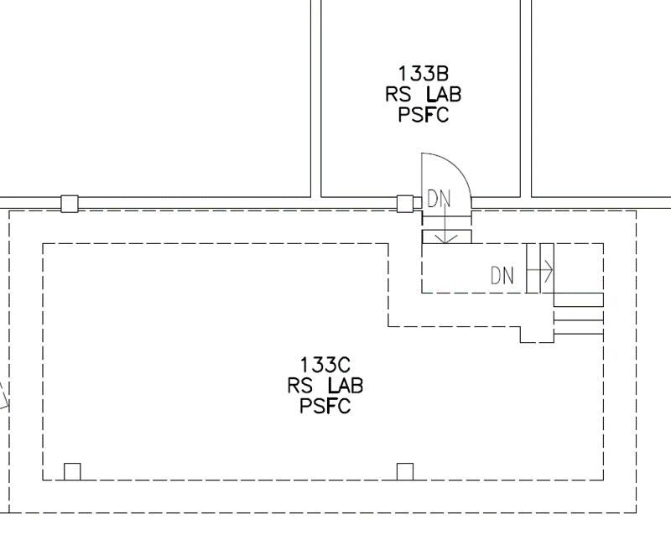
Linear Accelerator

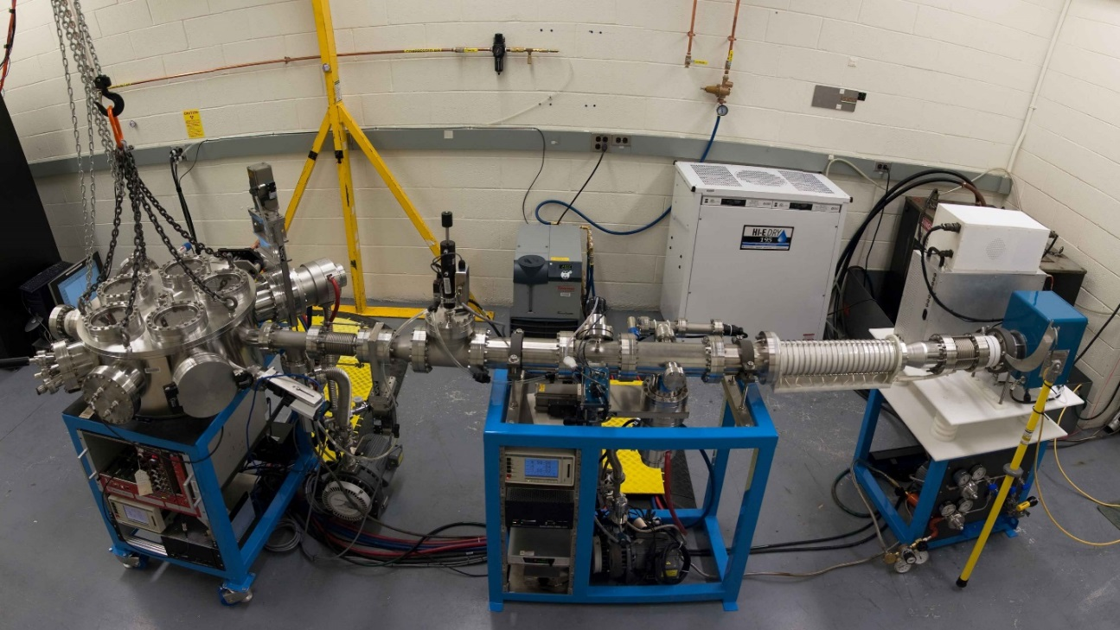

- Interlock Diagram
The high voltage interlock circuit is a series circuit of the door interlock, emergency off, and computer high voltage button. There is also a separate interlock for the ion plasma, which is manually overridden during the working hours and turned off on weekends.

- General conditions relating to the application:

- The proposed work shall be performed in the manner specified above and on RP-81.0. There shall be no changes in the approved procedures without the prior approval of Radiation Protection and/or the Radiation Protection Committee as appropriate. RP shall be notified prior to a change in place of use of the equipment.
- The use of equipment shall be in conformity with the provisions of “M.I.T. Accelerator Radiation safety program”.

- Routine operating of this equipment may not begin until RP has been notified and has conducted a thorough survey and given approval for operation. Additional surveys will be made by RP annually, at which time adherence to the provisions of this registration and supporting documents will be determined.

- RP shall be notified of any changes in personnel with this equipment. All personnel shall be appropriately trained by RP and the supervisor before working with the equipment.

13. Project Supervisor’s Signature _________________________ Date ______________

Project Supervisor’s Name (print) ___________________________________________

