All uses of radioactive sources or radiation producing equipment (both ionizing and non-ionzing) must meet all federal and/or local regulatory requirements for licensing/registration.

Consideration should be given to having all laboratory door access (biological, chemical, and radiological) be controlled by card proximity readers. The doors would remain locked at all times and access would be granted only to person associated with the lab space who have completed the required EHS training. Experience has shown that card access control helps in compliance rates for required training, especially in areas that require some form of retraining. In addition, removing individual access to labs is easier than trying to collect keys when researchers permanently leave the lab. Lab doors should have auto-closing mechanisms. Access control and security monitoring is required for high activity irradiator labs. Access control is required for hazardous waste storage facilities.

The following list is a summary of the considerations on lab design and waste management for radiation laboratories and will be elaborated on in the following respective sections:

Ionizing Radiation facilities:
A. Radioactive material labs:
B. Irradiator facilities:
C. Analytical X-Ray labs:
D. Fluoroscope-diagnostic x-ray labs (vivarium):
E. Medical X-ray Rooms
F. Dental X-ray Rooms
G. Positron Emission Tomography (PET), Computerized Tomography (CT) and Imaging Labs (vivarium)
H. Accelerator facilities
I. Other Machine Produced Radiation Facilities
J. Waste Management Facilities (Radioactive /Regulated Medical)

Non-Ionizing Radiation facilities
- NMR/MRI/EPR and other Strong Magnet Use Labs
- Laser Labs
- Radiofrequency - RF

- Ionizing Radiation Laboratories and Facilities

Radioactive Material Labs

Access controls are required for high activity irradiator labs and hazardous waste storage facilities. Additionally, high activity irradiator labs require security monitoring.

All uses of radioactive sources or radiation producing equipment must meet all federal and/or local regulatory requirements for licensing/registration.

Standard laboratory design with a few additional considerations:
- A multi-user “hot lab” where the bulk of the radioactive material experiments will be performed and the stock radioactive material will be securely stored. This lab would be shared by many researchers for initial labeling experiments. Only lower activity samples would be taken to the individual labs for further experimentation. The floor in this lab should be rolled, seamless vinyl for ease of decontamination. Bench surfaces should be impervious to allow for ease in decontamination.
- Laboratory doors should be equipped with access control (card key access is preferred to allow access to only trained radiation workers).
- Specialized ventilation is required if work will involve volatile radioactive material. This hood should probably be located in the multi-use “hot” lab and would be equipped with the appropriate filtration system (activated carbon or HEPA).
- Fume hoods should have a stainless steel interior for ease of decontamination. Ventilation ductwork can be PVC.
- Air sampling capabilities within the ductwork to assess potential releases of volatile radioactive material need to be considered.
- Sink for disposal of aqueous, biological, soluble liquid waste that meet regulatory requirements. Sink controls should be a foot pedal style (hands free)
- Lab entrance posting receptacle for required regulatory warning postings and emergency response information.

Irradiator Facilities

Radioactive Material Irradiators

If the facility/laboratory will require high activity gamma irradiators containing category 1 or category 2 radioactive sources (thousands of curies of activity), consideration must be given to physical security requirements.

Standard laboratory design with additional considerations for security system recommendations:
- Consideration for floor loading as these units can weigh between 6000-9,000 pounds.
- Typically 220V electric supply.
- The room should have floor to ceiling brick walls, not sheetrock.
- Room supply/exhaust air system ductwork should be less than 12 inches in diameter.
- Room must have access control system utilizing both proximity card access and biometric validation for unescorted use. The access control system will be alarmed to detect any unauthorized/forced entry or a door held open for a defined period of time.
- Room will be supplied with motion detectors to alert security to any unauthorized access.
- Room equipped with radiation dose rate level monitors to alert security to the detection of abnormal radiation levels. Monitors will have fixed set points that when exceeded will send alarm to security.
- Panic buttons within the room to allow user to contact security in an emergency situation.
- Room equipped with a camera/video system to allow security to triage alarm conditions and report to emergency first responders the conditions within the room.
- Cameras/video should also be in the corridors leading to the irradiator facility to monitor entrance/exit.
- A telephone within the room to allow for communication with security.
- A 24/7 facility security monitoring station (dispatch) to monitor alarms from the irradiator facility to enable appropriate emergency response depending on the alarm conditions.
- Secure transmission of security communications between the facility and the security monitoring station.
- Emergency back-up power required for security system.
- Lab entrance posting receptacle for required regulatory warning postings and emergency response information.

X-Ray Irradiators

- Consideration for floor loading as these units can weigh between 6000-9,000 pounds.
- Typically 220V electric supply.
- Lab entrance posting receptacle for required regulatory warning postings and emergency response information.
- Room shall have access control system. Utilizing proximity card access is highly recommended.

Analytical X-Ray Labs

Standard laboratory design with a few additional considerations:
- Consideration for floor loading as these units can weigh thousands of pounds.
- Typically 220V electric supply.
- Analytical x-ray machines with an open beam configuration, consideration must be given to either integral shielding within the facility walls, doors, and/ or isolation barriers.
- Fully enclosed or cabinet type analytical x-ray equipment that does not emit any increased radiation levels outside the enclosure requires only standard lab design.
- X-ray on warning light at lab entrance may be required.
- Room shall have access control system. Utilizing proximity card access is highly recommended.

Fluoroscope-Diagnostic X-Ray Research Labs

Standard laboratory design with a few additional considerations. The MIT Radiation Protection Program shall be consulted during the design and review process.

- Typically 220V electric supply.
- Integral shielding in walls, ceiling, and doors must be considered depending on the x-ray machine use.
- A control booth for the operator with leaded walls/viewing glass may be necessary.
- An interlock and/or warning light shall be installed at all egresses. For diagnostic x-ray installations, the warning light shall be wired to the rotor of the x-ray system.
- Consideration of the projected use of adjacent rooms/spaces and their occupancy factors to assist in shielding design.
- If located in a vivarium, the room may have special ventilation requirements.
- Room shall have access control system. Utilizing proximity card access is highly recommended.
- See 105 CMR 120.400 “X-Rays in the Healing Arts” for additional requirements set forth by the Massachusetts Department of Public Health Radiation Control Program.
- See NCRP Report No: 49, “Structural Shielding Design and Evaluation for Medical Use of X-rays and Gamma Rays of Energies up to 10 MeV.”
- Prior to construction a shielding plan shall be submitted to the Radiation Control Program for review and approval.

Medical X-ray Rooms

Standard medical room design with additional considerations. The MIT Radiation Protection Program shall be consulted during the design and review process.

- Typically 220V electric supply.
- Integral shielding in walls, ceiling, and doors must be considered depending on the x-ray machine use.
- A control booth for the operator with leaded walls/viewing glass may be necessary.
- An interlock and/or warning light shall be installed at all egresses. For diagnostic x-ray installations, the warning light shall be wired to the rotor of the x-ray system.
- Consideration of the projected use of adjacent rooms/spaces and their occupancy factors to assist in shielding design.
- If located in a vivarium, the room may have special ventilation requirements.
- Room shall have access control system. Utilizing proximity card access is highly recommended.
- See 105 CMR 120.400 “X-Rays in the Healing Arts” for additional requirements set forth by the Massachusetts Department of Public Health Radiation Control Program.
- See NCRP Report No: 49, “Structural Shielding Design and Evaluation for Medical Use of X-rays and Gamma Rays of Energies up to 10 MeV.”
- Prior to construction a shielding plan shall be submitted to the Radiation Control Program for review and approval.

Dental X-ray Rooms

Standard dental room design with additional considerations. The MIT Radiation Protection Program shall be consulted during the design and review process.

- See 105 CMR 120.400 “X-Rays in the Healing Arts” for additional requirements set forth by the Massachusetts Department of Public Health Radiation Control Program.
- See NCRP Report No. 145: Radiation Protection in Dentistry of additional requirements.
- Prior to construction a shielding plan shall be submitted to the Radiation Control Program for review and approval.

Positron Emission Tomography (PET), Computerized Tomography (CT) and Imaging Labs (Vivarium)

Standard laboratory design with a few additional considerations:

- Facilities that require the use of PET-CT equipment (typically in the vivarium), consideration must be given to assess the necessary shielding required in the lab to minimize worker and adjacent room public exposures. Portable and fixed lead shielding may be necessary depending on the types and amounts of PET isotopes to be used. Integral wall-door shielding may also be necessary.
- Laboratory doors should be equipped with access control (card key access is preferred to allow access to only trained radiation workers).Chemical fume hoods should be stainless steel to allow for ease of decontamination. Specialized ventilation is required if work will involve volatile radioactive material (radio-iodination experiments). This hood would be equipped with the appropriate filtration system (activated carbon or HEPA).
- Fume hoods should have a stainless steel interior for ease of decontamination. Ventilation ductwork can be PVC.
- Air sampling capabilities within the ductwork to assess potential releases of volatile radioactive material need to be considered.
- Sink for disposal of aqueous, biological, soluble liquid waste that meets regulatory requirements. Sink controls should be a foot pedal style (hands free).
- PET isotopes generally have short half-lives so consideration should be given to having adequate decay-in-storage space to house radioactive carcasses until they are no longer radioactive and can be disposed with other animal carcass waste. Lab entrance posting receptacle for required regulatory warning postings and emergency response information

Note: If the facility is considering installation a cyclotron to produce their own PET isotopes, there are many considerations/requirements for the appropriate shielding, delivery systems, ventilation, security, that must be encompassed into the cyclotron facility design. This design would require the assistance of the RPP.

Accelerator Facilities

Accelerator facilities range from simple to very complex systems. The requirements of 105CMR120.700 and 105CMR120.200 shall be met and the Radiation Protection Program must be contacted in the early design considerations to ensure shielding designs are appropriate for the facility. In addition the ANSI N43.1, Radiation Safety for the Design and Operation of Particle Accelerators should be consulted in the design phase.

Local Shielding
Accelerator facilities have the potential to create radiation levels outside the facility that are higher than the regulatory limits. Typical shield walls are on the order of several feet of concrete. Therefore, EHS Radiation Protection should be contacted to verify the accelerator shielding (local and/or walls) is adequate.

Interlock/Security Systems
Accelerator facilities are required to have significant access control/interlock/security systems due to the potential high radiation levels produced when the machine is running. Design of these system needs to be in consultant with an accelerator health physicist from the Radiation Protection Program.

Other Machine Produced Radiation Facilities

Other equipment that may produce ionizing radiation either as part of the design of the equipment or incidental to its operation will need to be reviewed with respect to possible radiation exposures, shielding, and engineering controls. The provisions of 105CMR120.200, 120.020, 120.600, and 120.700 may apply. An example of other machine produce equipment may be a gyrotron or klystron.

Waste Management (Radioactive/Regulated Medical)

Low level radioactive waste typically falls into the following categories:

- Solid radioactive (paper, plastic, glass)
  - Will be segregated by half-life in appropriate containers at the lab level to ensure proper disposal management. Short half-lived waste should be managed by decay-in-storage and ultimate disposal when the waste is no longer radioactive. Long half lived solid waste will be packaged for ultimate off-site disposal.

- Aqueous liquid radioactive waste
  - May be disposed via the sanitary sewer system in accordance with local regulations or license conditions or collected and stored for off-site disposal.

- Mixed chemical-radioactive waste
  - Must be stored for ultimate off-site disposal. If short half-lived, the waste may be stored until no longer radioactive and disposed as chemical waste.

- Animal carcass waste
  - Should be stored frozen until ultimate off-site disposal.

- Radioactive waste
  - Needs to be removed from the labs on a frequent basis.
  - Local storage rooms may be a consideration until the waste can be transferred to a central processing/management facility.
  - An appropriately sized central waste management facility must be available to store radioactive wastes until ultimate disposal.
  - The facility should be equipped with a chemical fume hood for sampling of radioactive liquid waste as necessary,
  - Chemical storage cabinets for mixed chemical-radioactive liquid waste
  - Freezers for animal carcass storage.
  - The facility should be secured by access control and intrusion alarms.
  - The facility should have the appropriate fire suppression system.

- Biological contaminated waste:
  - Biologically contaminated solid waste will be segregated at the lab level and collected for disposal. There are three options for managing this waste stream.
    - Collect the waste from the laboratories and transport to a central processing facility for treatment and disposal as non-regulated waste. The central facility would need to be equipped with a large scale autoclave and trash grinder prior to the disposal of treated waste as regular trash.
    - Collect the waste from the laboratories in containers that can be transported offsite for processing/disposal.
    - Provide autoclaves for each lab area and have the researcher’s process and manage their own non-sharp biological waste. The disinfected (autoclaved) waste can be disposed as regular trash. Separate containers for sharp biological waste would need to be provided. This waste would be collected and treated as #1 or #2 above.

Note: Do not short change the amount of space required to have a well-functioning hazardous waste management program. This includes:

- Designated areas in the lab for waste collection containers,
- Temporary consolidation storage spaces for waste near the point of generation, and
- A state of the art central waste processing/storage facility.

II Non Ionizing Radiation

NMR, MRI, EPR and Other Strong Magnet Use Labs

If the facility will require the use of equipment that may generate large magnetic fields such as MRI/NMR/EPR, consideration must be given to assess the necessary magnetic field shielding requirements:
- in the walls
- ceilings
- doors

The above should take into account the location and strength of the magnetic fringe fields with respect to exposure to individuals with pacemakers and other regulatory requirements.

In addition, cryogenically cooled magnets using Liquid Nitrogen and possibly Liquid Helium may require oxygen deficient monitoring tied to the TGMS and may require ventilation for magnet quench. In addition, considerations must be given to storage space for liquid nitrogen/helium dewars as needed.

A lab entrance posting receptacle for required regulatory warning postings and emergency response information will be required and if needed area and/or floor postings of fringe fields needs to be considered. A receptacle inside of the lab door for lab occupants to place credit cards, watches, cell phones, etc. may need to be considered depending on the strength of the magnet.

Limits for personnel exposure can be found in the American Conference of Governmental Industrial Hygienists (ACGIH) “Threshold Limiting Values (TLV) guidance on Static Magnetic Fields” and/or the International Commission on Nonionizing Radiation (ICNIRP) “Guidelines on Limits of Exposure to Static Magnetic Fields”. In addition magnetic resonance imaging systems for human subjects should follow the American College of Radiology Guidance for
Safe MR Practices.

Laser Labs

Laser radiation emitted from Class 3B and 4 lasers are considered to be potentially hazardous. Proper lab design can mitigate these hazards. This section is divided into two parts, covering both the exterior and interior design of a laser lab.

A visual overview of the safety requirements for a laser lab are provided in Figure 1 below.

Figure 1: Laser Lab Template
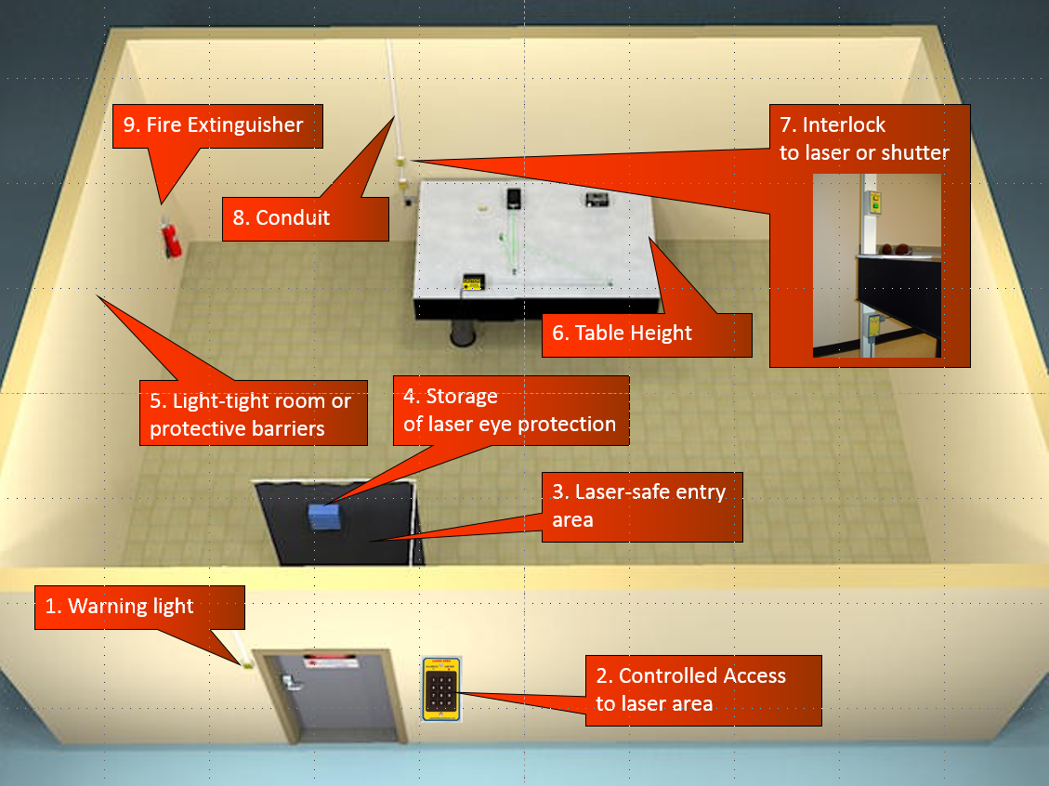

Section 1: Exterior Design

This section provides requirements and recommendations for the exterior of laser labs.

Access Controls / Controlled Entry
Class 3B and 4 laser labs require access control. The three most common controls are:
- Door interlock systems
- Electronic lock (keypad / RFID)
- Hazard posting

An MIT Laser Safety Officer from EHS Radiation Protection shall be consulted to determine the required access control system for an individual lab. If a laser interlock system is required, it must be such that the interlock must be armed first to allow the laser to be turned on. An interlocked system is not always the best solution. Interlock systems must only cause the laser beam to become safe when tripped. This is often achieved by dropping a shutter or causing the laser to lose power (least favored approach).

Door Interlock System
- The interlock must be armed to allow the laser to be turned on
- Non-defeatable door interlock is not a viable option. This type of system is designed to block the beam or drop power every time the door is opened.
- Defeatable door interlock is set with an access device on the outside (i.e. key pad or card key reader) that allows authorized staff to enter. Triggering the device sets a pre-determined (15-30 second) bypass where the door can be open and the laser will stay on. For example, Figure 2 shows the Kentek ‘Entry Guard’ Laser Safety Interlock System.

Figure 2: Laser Safety Interlock System
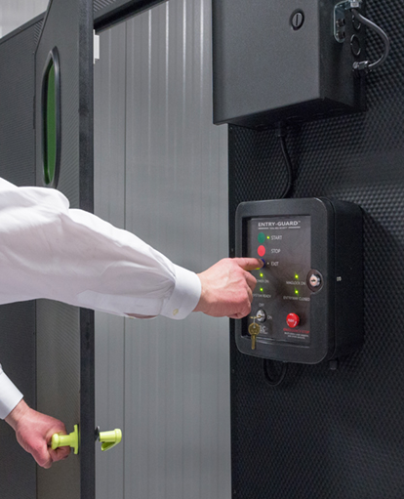

Door Notes
- Standard door safety requirements
  - Self-closing device on door required for laser labs
  - Standard keyed lock should not be used when possible.
  - Doors to lab should not be fire-rated unless necessary
  - Doors must be light tight, i.e. a strip at the bottom of the door similar to weather stripping or if a two (2) door access system, a light blocking strip between the closed doors (astragal).

Electronic Lock
- RFID card access or Cipher lock with key override: this approach provides secure access but has no effect on laser operation. The key override is for first responders only, not housekeeping.

Illuminated Warning Sign

A lighted laser sign outside each entryway to the laser controlled area is required. The lighted sign must illuminate only when the laser system is operating. The lighted sign should be at eye height at the outside door. This signage is provided/specified by MIT EHS. The power to the laser warning light should be interlocked to the power supply for the laser.

Laser warning Sign Conditions
- Posted at eye level (60” above the floor) to the side of the entryway, not above the door frame
- LED light source rather than standard bulbs
- The illuminated sign is required for each doorway that is accessible
- Illuminated whenever the laser is energized and capable of producing a beam
- Automatic light, light turn off/on based on when the laser is on/off
- If light manually controlled, light switch shall be located in a convenient position near the laser control. The light switch should identified by a label.

Eyewear Storage
A critical element of laser safety is laser protective eyewear; hence, the storage and protection of that eyewear is very important. Laser eyewear can be stored inside or outside of the laser use area or at both locations. The storage device must protect the physical integrity of the eyewear and be easily accessible to the users.

Storage Considerations
- If multiple lasers are present, store in a way to avoid confusing different types of eyewear
- Laser safety eyewear can be stored in the typical “cubby-hole” or “mailbox” type of storage rack.

Windows
In general, windows should be avoided in the design of a laser lab as they will need to be covered. If doors are equipped with windows, the following needs to be considered:
- Window panels in doors should be covered with a permanent opaque material.
- If windows are required for non-laser use periods, then shades or removable covers for laser operation need to be available.
- Electronic shutter windows can be used in some circumstances
- Windows can be covered with optical density acrylics to provide protection and viewing. Such acrylics must be labeled with wavelength and optical density.
- Portals/viewing windows must be designed to prevent any exposure above the maximum permissible exposure value. Contact EHS Radiation Protection for support with this evaluation.
- Wall windows should be treated the same as door windows.

Section 2: Interior Design

This section provides requirements and recommendations for the interior of laser labs.

Fire Suppression
As a guideline, lasers with powers greater than 10 Watts or with irradiances greater than 10 W cm⁻² have the potential to create fires if misaligned.
- Provide proper fire extinguisher or room fire suppression system.

Emergency Lighting
Emergency lighting should be evaluated with guidance from the Safety Program.

Emergency power off (EPO)
A red mushroom type button or equivalent must be easily accessible in an emergency to kill power to the laser system.

Conduit
Wiring channels should be run for interlock controls and remote firing/monitoring if applicable. If lasers are to be transported via fiber optics, a separate conduit should be made with appropriate labeling.

Optical Table
- The tables will need to be grounded
- The laser beam should be below or above eye-level when sitting or standing
- Vibration dampening is a consideration for laser optical tables.

Walls/Enclosures/Barriers
Depending on the experimental set up, several means of beam containment are open to the user. One is to install interior walls around the laser set up. This type of enclosure needs to be at least several inches higher than intended beam path.

Walls should be painted a non-reflective color such as a matte black. There should be no reflective materials in the lab such as corner protectors on walls.

Complete Table Barriers
These units are 80/20 frames or Uni-strut that stand a few inches off from the optical table and have a track for panels (most commonly sliding panels). Frames can be equipped with HEPA Filters, lights or no roof at all.
- Around entire table or portion of it
- Can be open or closed on top
- May need task lighting
- Items stored on top must be seismically braced

Work Station
When a computer workstation exists within the lab, laser protective eyewear needs to be removed to see the screen.
- Take steps to ensure there are partitions, perimeter guards, or equivalent means to allow safe viewing of computer screens
- These should not be at the same level as any open laser beams

Equipment Rack Unit
At times, laboratory equipment will be placed in instrument racks. When using these, one needs to make sure they are:
- Seismically braced
- Grounded
- Special note: equipment made to be rack mounted, used outside of the rack, needs to be grounded

Laser Safety Curtain Area
The purpose of a curtain area is to protect the doorway and/or eye-safe areas of the room. These curtains should have the following properties:
- Allow enough room for people entering to put on eye protection
- No line of sight between room entrance / eye-safe areas to optics / laser
- Do not allow it to interfere with fire suppression sprinklers. Hang from track with rollers without blocking sprinkler patterns and extend from the floor to ceiling
- Curtain systems should consider local fire code requirements and as a minimum meet the requirements of NFPA 701 and ANSI Z136-2014 (see Radiation Protection for details). Fabric should be fire resistant:
  - Prevent combustion when hit by enclosed laser beam
  - Shall not off-gas
  - Shall be flame-retardant/flameproof/laser rated
- Fire detection systems coverage should be considered
- Curtain overlap should be 12” for vertical curtain pieces or have a closure device
- Do not hang from floor to ceiling unless required for lighting control conditions

In addition, the laser safety curtain area shall contain:
- Laser Protective Eyewear Storage (if inside the room)
- Emergency cut off switch installed near entrance of lab to turn off laser remotely

Fumes / Gas Cylinders
- Laser facilities using toxic gasses or burning/cutting must have the appropriate ventilation (such as toxic gas cabinets).
- If hazardous chemicals will be used a chemical fume hood must be available
- Appropriate eyewash/shower and other safety considerations shall be provided as appropriate.
- Gas cylinder storage (restraints) shall be provided.

Radiofrequency - RF

Systems that emit radiofrequency (RF) energy as an intentional emitter may need to be reviewed if system power is in excess of 5W Effective Isotropic Rated Power (EIRP) to ensure that exposure levels meet the requirements of the MDPH 105CMR122.000 and those of the IEEE C95.1. Unintentional emitters shall be shielded to preclude exposures in excess of the limits in the regulations and standards as noted above. All systems shall be designed to operate in a non-interference mode in accordance with 47CFR15 which may require the use of RF shielding.

